**Final Project VB.net**

Herzing college

|  |  |
| --- | --- |
| Project Description | Video Buster |
| Students | Ritu Bhatt  Kartavya  Sukhwinder kaur |
| Course | VB.Net-Block3 |
| Teacher | Gerorge Boursiquot |
| Date | November 8, 2019 |

**Final Project VB.Net**

Herzing College

**CONTENTS**

*Introduction……………………………………………………………………………………....…Page 3*

*Analysis…………………………………………………………………………………………….….Page 4*

*Implementation…………………………………………………………………………………...Page 6*

*Discussion…………………………………………………………………………………………….Page 13*

*Conclusion……………………………………………………………………………………………Page 13*

*References…………………………………………………………………………………………..Page 13*

**Final Project VB.Net**

Herzing College

**INTRODUCTION**

*This project creates a* ***Video Buster*** *where clients can register yourself, edit their personal information, and can delete their data from database. Apart from this, client list can be view by employees but employees list can view only by employees not by clients as well as clients details can also be edit, delete and add. Likewise, if someone forget their password, they can reset their password and login with new password. Last but not the least, employees can add, edit, delete videos whereas clients can take videos on rent and return it on time and also view the list of videos.*

*This report is allow the employees to see how the clients can view, rent and return videos as well as he/she can understand the flow of system. This report covers the pros and cons of project and how we resolved barriers coming in between. Also, it defines functionalities of the system.*

**Final Project VB.Net**

Herzing College

**Analysis**

*The project required a discussion of the requirements and planning to implement Use Cases. Our team started the project by dividing same work between all of us with mutual understanding .Next, we discussed, what we have learned about vb.net and how we will implement that knowledge in our project. After making sure we have covered all the functionalities, we next talked about the team’s “Coding Structure”. Then, we discussed our step by step process of the project and we worked on that.*

*\*\*Program Class Diagram is given below\*\**

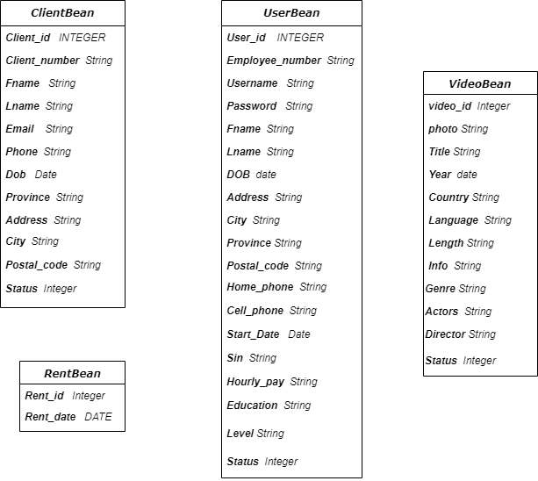

**Final Project VB.Net**

Herzing College

*\*\*Database Class Diagram is given below\*\**

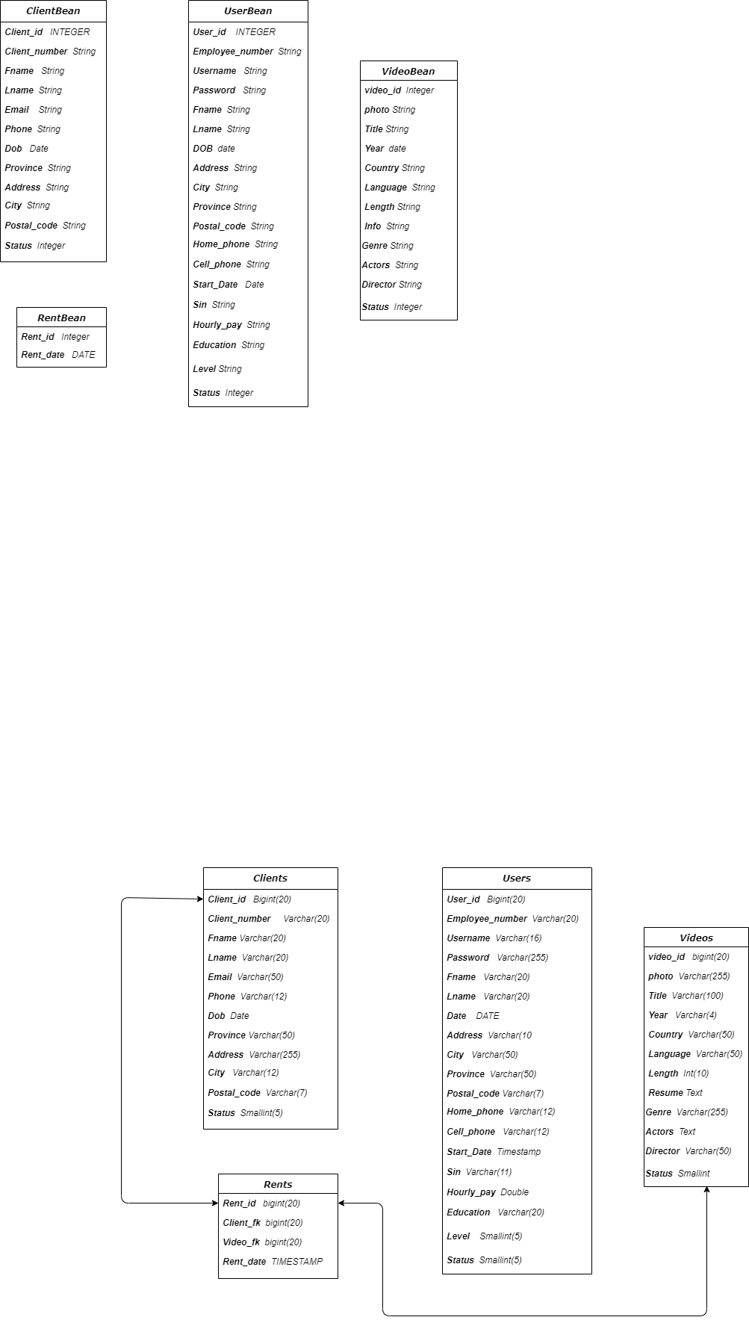

**Final Project VB.Net**

Herzing College

**IMPLEMENTATION**

*The first step of the project was to decide who is going to do which part of project and which shows their abilities that how fast we could complete this. We begin by creating all form of clients, employees etc. After that we decided to make classes and do the connectivity of database. After that, the most important part of our project is validation. Without that, project was nothing. So, we equally divide the different forms for validation. Last but not the least, after validation, designing is also important part of the project. Last part of our project was designing. We equally decide the wallpaper and themes for the forms.*

**Final Project VB.Net**

Herzing College

**DISCUSSION**

*The fact that we did not have learn how to implement and connect to a database, made it a bit difficult and tricky on how to save created users as well as other information inputted by the user. We decided to create a “Database connectivity” which would hold all information given by a user.*

**CONCLUSION**

*YES, We have completed our project on time. It was possible due to the effort of each member. Our team leader played good role during project. She divided work equally and gave a deadline for completing our work. Each member followed her words. This was the reason behind completing our project on time.*